Appendix 1: HRA Development - Site Plans - Cabinet Report 9th September 2020

Northfield Hostel Site

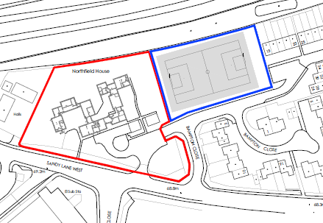

Red line – Land proposed to be purchased by Oxford City Council
Blue line – Land proposed to be retained by Oxfordshire County Council

Lanham Way Site

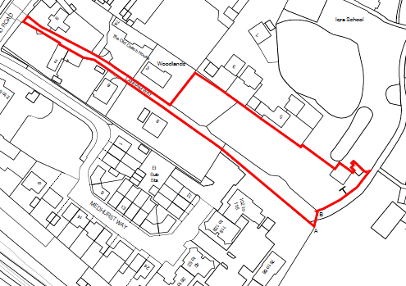

Red line plan – also showing easement along Lanham Way, although access into the site would be proposed from Medhurst Way which is unimpeded by other ownerships/ no ransom strip

